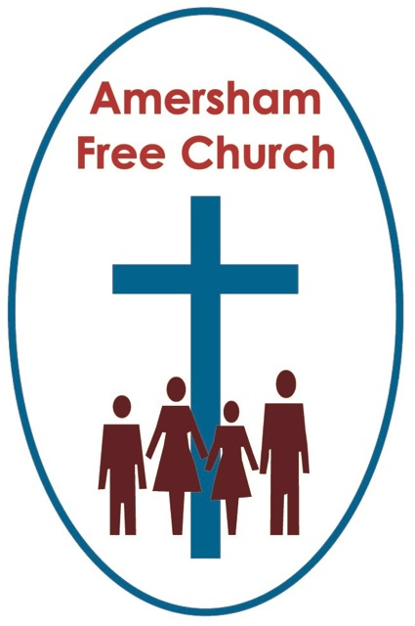
Psalm 22.23-31
Mark 8.31-38
25th February 2024

What sort of Jesus do we believe in?

Gracious God, we thank you for your word in scripture and made flesh in the Lord Jesus Christ. Help us now to catch your voice and speak, we pray, to our hearts and minds. In Jesus’ name. Amen.
It’s a question for the whole of the year, but especially Lent: What sort of Jesus do we believe in?
I have learnt to look more closely at religious art since being here at AFC and I’ve loved the Art in the Corridor project headed up by Liz.
And in the paintings we display Jesus is, indeed, depicted differently by a variety of artists, all with their own understanding of who he was and what he represents.
Because a member of the congregation recently gifted me a book of the religious art of James Tissot, I’ve spent a bit of time this winter reading up about his fascinating life. He could so easily have thrown his lot in with the French Impressionists, yet choose, especially in his final decade to make a study of Jesus. He visited Israel three times to do his home work and painted no less than 350 images of Jesus and the gospel stories.
The paintings of the Catholic priest, Father Seiger Koder are very different, and I think much loved by many of us here at AFC. Tissot’s style was realism, Koder is much more interpretive. He was a prisoner of war and his wonderful paintings are influenced by the horrors of the holocaust. Koder’s Jesus always seems full of kindness and compassion.
Because the truth is – there are many versions of Jesus in Christianity – and perhaps in our own pilgrimage we’ve held a variety of ideas about him at various stages of our lives.

Well. this Lent our Art in the Corridor project has paintings by both Tissot and Koder, so do have a look.
So, our lectionary reading this morning has Jesus telling the disciples something about himself and his mission – a moment of self-disclosure. Mark has Jesus declare that he will soon suffer, that he is on a course that will lead to his rejection and ultimate premature death. This wasn’t the most optimistic life plan to share with your followers, for in so many ways this was beginning to feel like a mission that would end in apparent failure rather than a storming success.
Perhaps he had got it wrong. Maybe he was being far too pessimistic. Peter certainly thought so. And if Jesus was right – then why had these disciples left everything and signed up for a mission that was now seemingly doomed?

Yet Jesus is adamant in Mark 8. This is me, he says. You need to accept this is me and this is our mission.
Maybe it feels to us as we read this chapter that Jesus is doing some necessary work here. He’s correcting the dominant image of Messiahship which is held by those around him. If they thought of Jesus in terms of power, bringing back an indigenous government, overthrowing Roman imperialism – then they were backing the wrong horse. Indeed, our first reading this morning has echoes of that in Psalm 22, verse 28: For kingly power belongs to the Lord, dominion over the nations is his.
The titles we give to God matter because within them we invest our understanding of God.
I was a little surprised to be at a meeting alongside some Liberal Jews who told us they now rarely use the term ‘Lord’ for God because they view it as oppressive.
Indeed whenever we use the terms King or Father for God here in our worship it’s probably good for us to expand on them and tease out what sort of King and what kind of Father we are thinking of as we describe God in this way.
It can be helpful even to think of alternatives to a trinitarian blessing and come up with something like: Creator, Redeemer and Sustainor, because it makes us think deeper about our faith and the God in whom we trust.
Well here in Mark 8 Jesus seems to quite deliberately use a title for himself – that of Son of Man – to say something significant about who he is and what he has come to do.
In ‘Bible speak’ Son of Man is primarily a term that emphasises his, and our, humanity.
So, setting his face towards Jerusalem, anticipating all that will lead up to Easter, Jesus doesn’t refer to himself as Son of God but Son of Man.
This, quite simply, isn’t about a mission based on power and carried out in the vein of a kingly liberator. Jesus shows us in his humanity what the best sort of humanity looks like. For at its best humanity is about sacrificial service and compassionate living.
Someone has this play on words - which is worth thinking about, that the mission and person of Jesus wasn’t essentially about Kingship, but Kinship. Take out the ‘g’ and Kingship becomes Kinship – Jesus the Son of Man, one with us, our brother, our kin. As if Jesus is saying to us, by using this title: it’s my humanity that is worth celebrating. This is the way any human life can be lived. A life for others. A life of service. A life of compassion. This is the best of us, the best of our humanity – and I think Mark is saying to us this has never been more fully lived out than in the life of Jesus, The Son of Man.

The Roman politician Cicero said, around AD 60, looking back some 30 years that: The cross was always the destination of Jesus.
His message of love would be ignored, his call for justice would be misinterpreted and his acceptance of the marginalised would become overblown into a fake news scandal.
And the cross became his destination because he did not kick back. He meets hatred with forgiveness and violence with peace.
We were looking through a box of our children’s paintings from their Primary School Days a few weeks ago and came across one of two simple black brush strokes – the teacher had labelled it The cross of Jesus. Of course, on the one hand, I was glad to be reminded that in their early years our boys went to a school at which Lent, Good Friday and Easter found a place on the curriculum, even in art lessons. Yet, on the other, it made me realise once again that the cross isn’t an easy theological concept. We have to do a significant amount of reading, thinking and reflecting to come to an appreciation of what it might mean in our own faith construct. Merely painting two brush strokes and labelling it the cross of Jesus was never going to be enough!
So, in today’s passage Jesus kick starts that process for his disciples and says: I am going to suffer death because of what I say and stand for. That’s where this is going – a real death, in a real body, on a real cross.
So, where are we in this morning’s narrative? Jesus says: This is me, and the cross is my destination.
And right on que Peter blunders in with his protestations that Jesus has got it all wrong. And what follows next must surely be one of the tensest moments in the gospels.
Jesus shuts Peter down. That’s the verb that’s used – it means the same as shutting down the utterances of an unclean spirit.
It must have been far too reminiscent for Jesus of the time he had just spent in the Wilderness as the Devil tempted him to take the easier way. Now Peter is doing the same thing. ‘Be a different Messiah Jesus’, he says, but Jesus will have none of it and tells him to stop his diabolical talk.
Embarrassment all round. Maybe even the disciples, those closest to Jesus at this moment, were actually missing the point of what it was all about.
So, after telling them: This is me. And following Peter’s outburst Jesus ends this episode by saying to them: This is you – this is who you need to be. You need to be cross carrying disciples. If you are my followers, you too need to live with compassion and self-giving love, because that is the way to live a fully human life. And if that self-giving life leads to personal suffering bear it with grace, carry it with forgiveness – just as Jesus did
Somehow, we recognise the heights of humanity when we see it. We recognise self-giving lived at personal cost and we realise that such lives represent the best of us, lives given in the service of others.

Of course, living like this is hard.
I read one bible commentator who sums up today’s passage and the injunction of Jesus to take up your cross this way: Christian faith is not a life choice; it is a vocation to never ending struggle.
I’m not sure how you market that? I’m not sure if it would work as a strapline for any church. I mean what would anyone make of a poster outside on Woodside Road that says: ‘Come and join us in the biggest struggles you’ll ever have – see you Sundays at 10.30am!!
But there is truth in that observation. Self- giving love is tough, and demands our all.
The essence of such love is its lack of self- interest and maybe selfless love is a very rare commodity.
Selfless love challenges us all.
Maybe it’s about standing by an addict, expecting nothing back.
Keeping the door open in a family feud even when over decades no one walks through.
It’s about a life of down to earth compassion rather than personal acquisition of wealth, power or adulation.
Cross carrying disciples don’t laud it over others, don’t insist on their own way. Cross carrying disciples think of others and do everything in their power to walk a way of peace – often at their own expense.
Jesus says in today’s passage: This is me – I’m going to the cross. Peter says Jesus has got it all wrong and is then rebuked by Jesus. And finally, Jesus turns to all his disciples and basically says: take note, my way of life is to be yours also.
Mark Twain once said: It ain’t those parts of the Bible that I can’t understand that bother me, it is the parts that I do understand.
Well, if we can begin to understand what Jesus is saying in our passage this morning about renouncing self and taking up a cross, then, with God’s help, as our Lenten journey continues, we need to be bothered enough to put it into practice.

Because that is our calling, a calling to be fully human and live life aware, respectful and considerate of others. So, as we are called may we be given grace to follow our cross carrying God. Amen.
Ian Green, Amersham, 20th February 20204

