**AMERSHAM FREE CHURCH  
Thursday 17th April 2025  
MAUNDY THURSDAY   
HOLY COMMUNION**led by The Revd Ian Green and Liz Waumsley  
 *Organist: Richard Brazier*



*Wherever you are on the journey of faith, you are invited to receive communion.   
If you are able, please stand for those parts of the service marked with an asterisk (*)*

**GOD INVITES US TO WORSHIP** **Welcome and Opening Responses**Leader: The darkness deepens, and the Lord grows troubled.   
 Can we watch with Him?   
 Can we be the friends at His table   
 who share His bread and wine?   
 Can we be the companions   
 who journey with Him to the end?   
**All: Come, let us worship, let us watch,   
 and let us give thanks for such great love.**   
Leader: The Lord be with you  
**All : And also with you**

**\* Hymn:**  Passover God, we remember your faithfulness *Tune: Was Lebet R&S 187***1. Passover God, we remember your faithfulness,  
God of the exodus, friend of the poor;   
People bowed down with the burden of powerlessness,   
Sin in its ruthlessness making them slaves.  
  
 2. Still people shrivel, imprisoned in bitterness,   
Hemmed in by fear and diminished by hate;  
 Tormented prisoners and perishing hungry ones,   
Broken humanity calls for your aid.   
  
3. You summoned Moses to work for the freedom march,   
You called the slaves to be people of hope;   
Set free from Egypt, you led them through desert lands,   
Loving commands gave them justice and truth.  
  
 4. You gave the travellers bread in the wilderness;  
 Strengthen us now with the bread that we share;   
Bread for the struggle and wine for rejoicing;   
In Christ you free us and teach us to care.   
  
5. We are your people, still called to a promised land,  
 Called for a purpose with Christ as the way;   
Grant us commitment to wholeness and liberty,   
Strength for the journey and grace for each day.**  *Christopher Ellis CCL257120***Opening Prayers of Praise, Confession and Lord’s Prayer**  
Leader: Lord Jesus, we are stunned at Your passion   
 and Your commitment toward us.   
**All: You did not run from the darkness,   
 You did not hide from Your accusers,   
 You did not fade into safe obscurity.   
 You stepped with determination into the darkness.**  
Leader: Willingly giving Yourself to whip and fist, to wood and nails.   
 We praise You, Gracious Lord, for what You   
 were prepared to endure to bring us peace.   
**All: We praise You, Gracious Lord, for Your words of   
 forgiveness, and the invitation to paradise.**   
Leader: Forgive us when we allow ourselves   
 to take Your suffering too lightly,   
 and receive Your grace too cheaply.   
**All: As we watch with You,   
 while the darkness encroaches,   
 Let us remember what this journey means,   
 and count again the cost of love. Amen.   
 WE LISTEN FOR THE WORD OF GOD**  
 **Readings**:Exodus 12.1-4, 11-14 p. 53  
 John 13.1-17 p.92   
 Reader: In this is the word of the Lord  
 **All: Thanks be to God***This evening’s reader is Beverley Underwood*  
 **Reflection followed by Prayers of Intercession  
  
 THE COMMUNION**

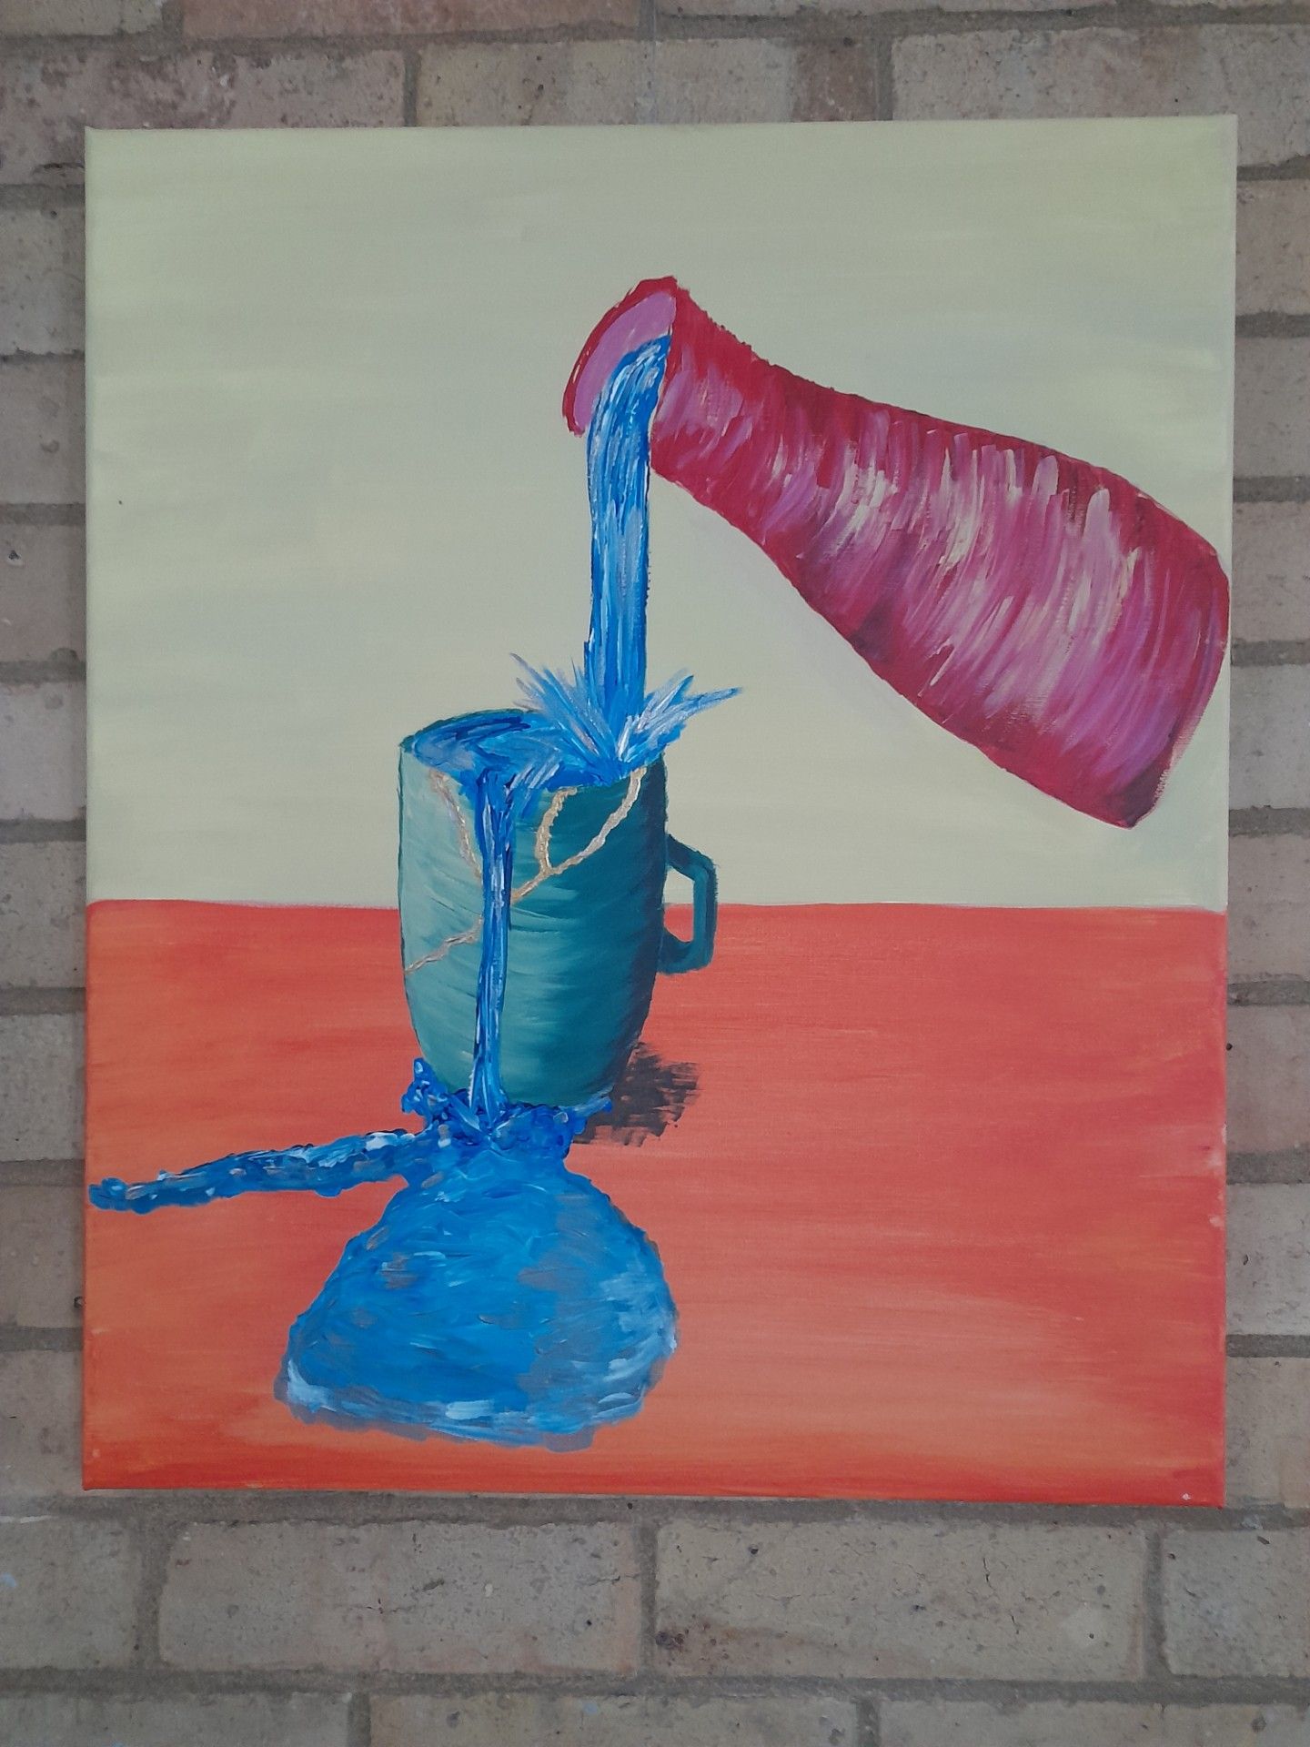

**\* Hymn 522:** From heaven you came  
 **\*The Peace** *all standing* Minister: The peace of the Lord be always with you  
 **All: and also with you.** Minister: We say for one another:  
 **All: The grace of our Lord Jesus Christ,  
 the love of God   
 and the fellowship of the Holy Spirit  
 be with us all evermore.  
  
Invitation to Communion  
  
The Great Prayer of Thanksgiving**Minister: Lift up your hearts.  
**All: We lift them to the Lord.**Minister: Let us give thanks to the Lord our God.  
**All: It is right to give him thanks and praise.**Minister:Therefore with all your people in heaven and on  
 earth we sing the resounding hymn of your glory:  
   
**All: Holy, holy, holy Lord,   
 God of power and might,   
 *Sung: 13 in*****heaven and earth are full of your glory.  
 *hymn book*****Hosanna in the highest.  
 Blessed is he who comes   
 in the name of the Lord.  
 Hosanna in the highest.  
  
Words of Institution and Sharing of the bread and wine**  
**Post Communion Prayer  
 Generous and Gracious God,  
 You have met us here in bread and wine,  
 Send us out with your love in our hearts,  
 And with your light to guide us upon our paths.  
 And so may we live the words we have sung,  
 To your praise and glory. Amen  
  
 THE LEAVING***As music is played, we leave in silence, gathering in the Sanctuary Vestibule to sing a closing hymn…***\*Hymn:** When I survey  
**When I survey the wondrous cross  
On which the Prince of glory died,  
My richest gain I count but loss,  
And pour contempt on all my pride.**



**Forbid it, Lord, that I should boast,  
Save in the death of Christ my God!  
All the vain things that charm me most,  
I sacrifice them to His blood.**

**See from His head, His hands, His feet,  
Sorrow and love flow mingled down!  
Did e’er such love and sorrow meet,  
Or thorns compose so rich a crown?**

**Were the whole realm of nature mine,  
That were a present far too small;  
Love so amazing, so divine,  
Demands my soul, my life, my all.**

**\*Dismissal and Blessing**