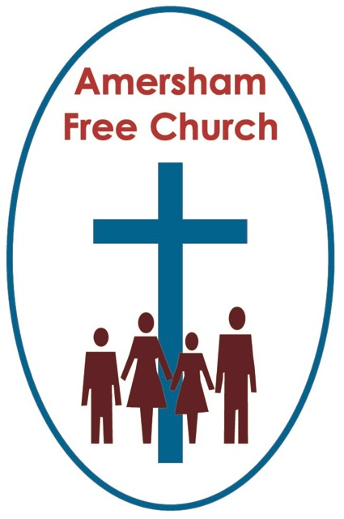
Isaiah 2.1-5
Mark 13.24-37
3rd December 2023 Advent 1
Keep Watch
Gracious God, we open the bible and long to receive your word.
Open, we pray, our minds and hearts to receive that word with all
its comfort and in all its challenge. Amen.
One of my tutors at Theological College constantly seemed to have his mind on higher things which made him utterly unable to cope with routine activities like turning up to the right place at the time. This wouldn’t have been a problem apart from the fact that as an ambassador for the college he was regularly booked to be in a different church most Sundays. On one occasion he told us, he turned up late and the service had already started, but he took the initiative and walked up the aisle into the pulpit. He thanked the man leading the service for so ably holding the fort, saying: you can go now and sit with his wife in the pew, I’m here and can take over.
Imagine his embarrassment when the man said, Sir, I think you are probably booked for the Baptist church down the road this is the Methodist one, I’m its minister and it’s probably best if I stay in the pulpit. Maybe today he might have added: You should have gone to Specsavers!
We’ll, we can all get our dates and times wrong, and when it comes to the idea of a Second Coming, well every predicted date has been wrong so far.
Traditionally during Advent, as we prepare to recall with thanksgiving the first coming of Jesus, we read some of the scriptures that point us to his second.
Today’s Gospel which kicks off the Year of Mark in The Church has the wisest of words: About that day and hour…no one knows. Be on your guard and keep watch.
Yet the return of Jesus was often written about by the authors of the New Testament, showing us that it was a hot topic in the first hundred or so years of the Christian Church with its members seeming to believe that such a Second Coming would definitely happen in their lifetime.
We learn from letters like Thessalonians that local churches could become obsessed by pointless speculation with some even believing Jesus had already returned and they had been left behind.
Perhaps, after 2,000 years we are not in the same place. Whenever I hear the phrase in church: Christ has died, Christ is risen, Christ will come again, I think just as much about the way Christ comes to our world everyday as much as I do about a coming on the final one.
That’s because a central and thrilling core belief in our Judaeo Christian tradition is that God comes among us, lives alongside us, makes himself known to us. Not a stoic, distant deity like the Greek and Roman gods of antiquity, but a sense that God touches our world with love, justice and joy every day.
Part of our mission is to do all we can to be good signposts for God, to help people connect.
The mission of the Church, in a way, isn’t to bring God into the world - for God is already here. Every word of love is a word from God, every act of justice is an act of God. But in the welcome we give at our Christmas events and in the words of the carols we’ll sing among our communities our prayer is that in this way it will be our privilege to point those we love to the God we love as we celebrate the way his love blesses all of us, wherever we are on the journey of faith.
That sense of connection is an important element in our pilgrimage. No doubt it ebbs and flows, yet God is always with us and comes to us each new day.
I love the story told by the former Archbishop, George Carey about the day he was installed at Canterbury. He was placed in St Augustine’s chair which is enormous, and George Carey said: Straight away as I sat down, I realised there was room for another, and then it came to me – it was as if God said, I will sit alongside you and this ministry will be about you and me together.
That’s connectedness. Making room for Another. And that’s a very personal understanding of the Coming of Jesus into our everyday lives.
So in this passage Mark has Jesus telling his congregation to Keep awake! I think every preacher secretly wants to say that from time to time! Become ‘present’ to the ‘presence’ of God.
In one sense that may indeed mean looking forward to The Day of The Lord in that traditional sense of The Second Coming.
In another it means rejoicing that This is the Day the Lord has made, we will rejoice and be glad in it. This day. Looking for the presence of God in the present, every day.
It's a call to live this day, this moment, this Advent Sunday 2023 as The Day of the Lord, to walk in God’s light and share God’s love today.
Now I know I’ve told you this a few years ago, (I mean that’s the trouble with this being my twelfth Advent here, you’ve heard all my stories before), but I always remember at this time of year that whilst living and working in Malvern, John Bell, the theologian and hymnwriter closely connected with the Iona Community visited our town for a conference. A charming lady from my congregation got alongside him and asked if would judge a carol writing competition we were having at our church. We gave everyone the same Welsh Tune, Suo Gan, and asked them to write a carol. To my astonishment John Bell agreed to receive all the entries, look them over and choose a winner.
I wasn’t surprised he selected Rosemary’s beautiful carol. She’d worked overseas with the BMS and she had a deep social conscience and a winning way with words. In each verse she pictured a scene, often from the developing world, one based on articles she’d read in the BMS magazine, and she thought about how God’s love that Christmas could enter into the lives of people who lived there. Unsurprisingly her carol was a reminder that it is often we who can bring God’s light and love. We can be Christ’s hands as channels of his light and hope.
Here are just a couple of her verses – probably best I read rather than sing them!:
Little Husein, son of Iqbal,
born to Hasma here on earth.
In Iraq and near a bombsite,
cruel was your human birth.
Seen by soldiers and policemen,
wondering what tomorrow brings.
We will pray and campaign for you,
listen while the whole world sings.
Baby Jevdet, son of Bekim,
born to Dona here on earth.
Now uprooted from your country,
seeking home and human worth.
Kept in makeshift refugee camp,
wondering what tomorrow brings.
We will speak and stand up for you;
listen while the whole world sings.
We can be Christ’s hands as channels of his light and hope.
We can make this The Day of The Lord for others.
Well, I must bring this talk to a close!
And I want to do that by noting that wanting to live with certainty is nothing new. Every generation would love to be able to plan a secure and predictable future.
I remember listening to a person describe himself and his wife as chart and compass people. That is, they loved to be in control and a good day for them was one with no surprises.
Yet, the truth is that nearly everything we are beginning to enter into those new diaries we are buying for next year should really be in pencil rather than pen.
It seems to have been the same in Jesus’ day. People were going around saying I know the date and I know how the future is going to pan out.
To all of this Jesus just replies: No one knows, not even the angels in heaven. And that Christlike view of the future reminds us of our human vulnerability. None of us know what tomorrow is going to bring.
So, is there any hope for us this Advent? Well, I think there is.
Goodness and mercy will follow us every day of our lives because God will be with us. Every day is indeed a Day the Lord has made.
It's the message of Advent and it’s a message of hope. We are all walking into an unknown future, yet the love and light of God goes with us.
May we travel well, in the name of God, Father, Son and Holy Spirit, who shares every step of the journey with us. Amen
Ian Green, Amersham, 29th November 2023

