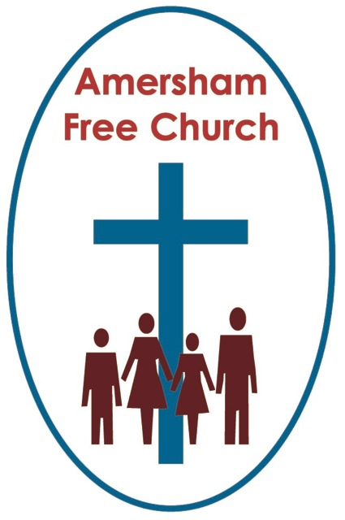
4th September 2022
Deuteronomy 30.15-20
Matthew 5.21-37

Choose Life

Minister: Gracious God, we open the bible
and long to receive your word.
All: Open, we pray, our minds and hearts
to receive that word
with all its comfort and in all its challenge. Amen.
Having a choice has, more and more, become seen today as an absolute right.
Part of the democratisation of society is that choice, when it comes to elections, is placed in the hands of the voters. So, for example, we wait with bated breath until tomorrow to see who the choice of the Conservative Party for their new leader is.
As I approached the last few months at theological college, we all had to become part of a process in finding a church that would want us as its new minister. I found there was very little choice for me in that process. I went in for an interview with the General Superintendent Minister of the Metropolitan Area of the Baptist Union who was arranging our introductions to the churches. I think I must have been the last one of the day, or something like that, because he looked me over and barked: Ah, you are young and single, so it will be an Assistant Minister’s position for you. Goodbye. And that was that! Actually, I had the best possible five-year apprenticeship as a result, so I was rather glad he made the choice for me.
Today’s passage from the Jewish scriptures is taken from the third speech Moses gives in Deuteronomy to a people on the cusp of a new chapter in their national life. Choose Life, says Moses. It’s a great sound bite and a wonderful rallying call. Make a choice, a deliberate and sustained choice, to look in God’s direction.
Towards the end of today’s reading all of this is encapsulated in a memorable triad of: Love God, Obey God and Cling to God.
Called by some as A Beautiful Synopsis of Life. Love, obey and cling. That, in Moses’ view, is a good choice.
Of course, Moses presents it as a stark binary option. Choose life and be blessed. Choose death and be cursed.
However, I suspect, as we look at life today, we are not convinced that it comes pre-packaged in simple and obvious binary options. Instead, most choices have shades of grey about them,
So, maybe Deuteronomy 30 needs a bit of work on it because we need some help in the choices we make, especially when the various pathways before us are anything but obvious. What do our two readings set for today, say to us in 2022 as we make our choices about life and living?
What is this life that we are called to choose? It’s not the High Life, or the Easy Life, no, it’s got something to do with God’s Life. So, here in God’s world, in a mysterious yet inspiring way, we are called to share in God’s Life.
There is, when it comes to faith, often an assumption, or a desire, that if it’s worth having it will give us all the answers and make life somehow easier. And when this doesn’t happen, well, we get disillusioned.
I can understand how reading the words of Moses this morning might lead us to rose tinted expectations. What does he say: See, I have set before you today life and prosperity, death and adversity. Well, that really is something of a stark choose and one that sounds obvious.
If this is no more than a:To be or not to be moment, then of course choose life and the attendant blessings that are promised will inevitably come our way.
But…did you hear a ‘but’ coming, it is, I suspect, one of the biggest of all myths when it comes to religion, to say that faith makes life easier. It’s never that simple.
Yes, the bible, I believe, talks of a fuller life, one that is more relational and has a deeper sense of joy and a determined sense of hope, but I don’t think it says that life lived in a God conscious way is inevitably easier than one that isn’t.
We choose it, though, because in the end we believe it to be the best choice, for a whole host of reasons, not all of them obvious.
Now, at this point in the sermon we’re still focused on the Old Testament reading, so why not take a brief glance at some of the characters from the Jewish Scriptures and ask the question: What did it mean for them to choose life.
How about David, King of Israel? He lived a phenomenally successful life, and his reign is thought of as a golden age. Yet he tripped up and committed adultery and murder. He wrote Psalm 51. probably the most personally penitential of any passage of scripture. David knew that living a life looking to God never meant temptation would go away, but that when we fall over new beginnings are possible.
How about Israel’s number one prophet Elijah, so revered that even today a spare seat is left for him at a Passover Meal. After his greatest triumph against the prophets of Baal, Elijah sinks into a deep depression and life becomes confused. He learnt that a life looking to God never means our emotions are always in balance, yet even at our bleakest moments God’s surprising hope can come our way in a still, small voice.
Or how about Ruth, the epitome of faithfulness. She marries into Naomi’s family, a Godward looking family if ever there was one, they even lived in Bethlehem. Yet this was a family that experiences cumulative bereavements. And Ruth learns that looking to God doesn’t save us from personal loss, yet she is blessed and becomes a blessing in her relationships with Naomi and Boaz, she finds love in the context of sorrow.
And finally, what about Joseph, the one famous for his coat. His family was the very foundation of Israel, yet his brothers hated and abused him. He was enslaved and imprisoned; the ingredients of a life that could, so easily and understandably, have made him permanently embittered. Yet he chooses life, God’s life, and when the moment came, he made what was probably the most important choice of his life, to forgive his brothers.
None of these heroes from the Jewish scriptures had an easy life, yet in all of their experiences they found a way forward based on love and trust which resulted in a life blessed by God in which new beginnings were found, deeper perspectives gained. A life in which love blossomed anew after bereavement and in which disappointment was corrected by forgiveness.
These were worthy lives even though they were tough lives. And most importantly of all these lives were grounded in God’s life. So, at moments when life felt like a failure, became confused, experienced yet another death or became stained by the abuse of another, these exemplars from the Jewish Scriptures found new beginnings, peace, hope and forgiveness. It’s as if something of God’s life brushed up against theirs and became that reservoir within that makes all the difference.
To choose life is to look to God – and we’ll spend a lifetime working out what that means!
So what of our New Testament scriptures? Jesus, just like Moses, speaks a lot about ‘life’, and said to his disciples he’d come to bring them abundant life.
So, what does the fullness of life look like for Jesus?
Well, in today’s passage it’s as if he is making life more difficult, certainly not easier. He’s interpreting the commandments giving them an even sharper edge. You have heard it said, but I say to you: Not only do not commit adultery but don’t lust after another person, not only do not murder but do not say angry words to them.
Jesus promotes a life that always seeks the best for the other. He even looses his own life on the cross because he stood up for the marginalised and oppressed.
It's the only life worth having, says Jesus; a life that is outward looking, relational, generous, kind-hearted and forgiving. But it often comes at a cost and it certainly is never easy.
That’s the covenant that God entered with his people all those centuries before Jesus: that he would be their God if they would be his people, that if they could in some small way reflect the life of God in their community then they would be light to the Gentles and give God glory.
I think one of the great miracles of life is when something of God and his life shines through our lives and makes the world a better, kinder and more dignified experience.
I don’t know whether you heard this wonderful story on the BBC morning service from Scotland last month; I’ll close with it now because I think it says so much of what happens when God’s life breaks through and touches ours.
The service came from The Edinburgh Festival and had a clip played back of the late Iain MacKenzie, musician and theologian recalling the very first festival and the closing concert on the last Saturday in the Usher Hall, one he attended and witnessed from the organ gallery.
After the savagery of the Second World War, the Festival brought back together the conductor, Bruno Walter, friend of Mahler with his beloved Vienna Philharmonic. That relationship, because of Jewish discrimination and persecution, had been broken, but that night old friends played together again. It was deliberate. The organisers of the Edinburgh Festival wanted it to stand for life, not death, and they believed in the healing power of music.
Iain MacKenzie said as he looked down from the organ gallery, as the Strauss Waltzes were played, he saw a friendship, a connection, even a celebration that was almost tangible between Bruno Walter and his old friends as they once again played together. MacKenzie said he looked over to a double bass player, the man had tears pouring down his face as he strutted his bow in time with the conductor’s baton.
It was a moment of life. And I think for those of us who believe so passionately in the Judaeo-Christian tradition, we would want to say it was a moment that had about it something of the life of God.
Thanks be to God for such moments. Thanks be to God for such life. Amen.
Ian Green Amersham 1st September 2022

