# 

# Genesis 45.1-15 Matthew 15.21-28

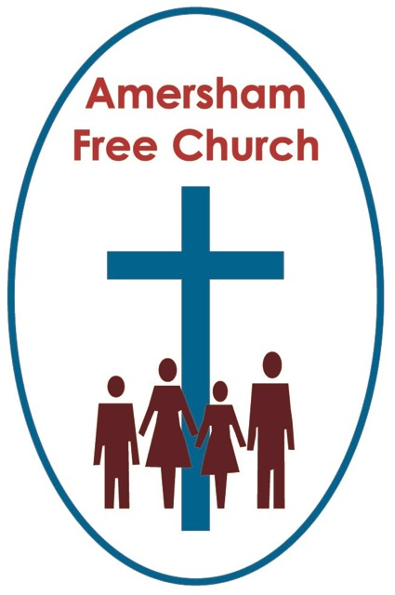

**20th August 2023**

## Chancing your arm

*For the Word of God in scripture  
For the Word of God among us  
For the Word of God within us  
Thanks be to God. Amen*  
  
Ernest Hemingway tells a story that goes something like this:  
A Spanish father and son had become estranged and grown apart. They hadn’t spoken for years and what had started as a minor difference of opinion had grown into a sad way of life between them. The son moved away and eventually the father tracked him down. He made his way to this obscure Spanish town and placed an advertisement in the local newspaper. Which read: *My dear son Paco, this is your father writing. I forgive you and want to meet with you. Please give me a second chance and be outside the newspaper offices at noon tomorrow.* The next day the father arrives at noon, and there outside the newspaper offices is a line of young men, about 30 in number, all with the name Paco hoping it was their father who had placed the advert.

Our longing for reconciliation goes deep. And today’s story, and it is essentially a story rather than a piece of history, has the theme of reconciliation at its heart.  
  
Of course, that’s a profoundly valued and important theme that runs all the way through the bible. Whether its Jacob’s reconciliation with Esau, Joseph with his brothers, the lost son being embraced by the loving father or Peter’s reinstatement by Jesus over a beach BBQ.  
  
And the idea behind all these wonderful and inspiring stories is that God loves the idea of reconciliation. Indeed, it’s one of the major themes of the cross.  
  
Joseph’s story is a hard one. His youthful arrogance always meant he was on a collision course with his brothers. He always outdoes them and jealousy builds.

Yet, we are none too sympathetic with them because their reaction was so brutally violent. Joseph is kidnapped by his own siblings and sold, deliberately, into slavery. It’s heartbreaking, especially for Jacob, their father.  
  
The twist is that, exceptionally – because this was never the norm – Jospeh does well in his adopted homeland and rises to the top. He manages a famine and becomes something of a Prince of Egypt. And then, at the height of his powers, who should turn up but the brothers who meant him so much harm, now come to ask for his help.

After some tense moments, when loyalties are tested, Jospeh reveals his true identity and the story climaxes with an emotional reunion.  
  
Now, I think we have to be just a little careful with this story. Because, although Jospeh says in the narrative, that although his brothers meant all this for ill, God used his kidnapping and slavery for good; that’s a statement that we need to think deeply about.  
  
We appreciate Joseph’s positivity here, indeed we might even applaud it recognising how it helped him move on instead of remaining bitter.   
  
But, in the words of one of my college tutors, for me I want to take Jospeh’s words more *descriptively* than *prescriptively.*

Of course, this is such an old story from the mists of time that we can’t be absolutely sure what is being said here.

But I think many of us would be uncomfortable with the notion that God, somehow, deliberately selected for Jospeh a pathway of human trafficking and slavery. I mean, would that tie up with all we learn in scripture about God wanting to bless us with his love and wholeness – what our Jewish friends rather wonderfully refer to as God’s *Shalom.*

For although Jospeh’s story came good, there would have been thousands around him who had been trafficked and enslaved for whom life remained totally wretched.

I would be uncomfortable with a theology that maintains God deliberately inflicts upon us bad things in order to teach us.

Rather, I believe that amid bad moments God is very near to us, offering us strength, hope, peace and perspective. In the words of Psalm 23 he walks beside us in the valley of shadows. Alongside us in pandemics, wars, famines and bereavements, and often – as with Jospeh – in the hardest moments we learn the most valuable of lessons.

And maybe the most valuable lesson to take away from this part of the story is the conviction with which Jospeh seems to speak when he thinks of God. He is so positive.  
  
Here is a man whose life might have crumbled under so much conflict from his past. He could have lingered over actions that were done both to him and by him, actions that were cruel and arrogant.  
  
Instead he turns to a better way, he turns to God, and instead of bitterness he embraces God’s love and hope. It’s the best of medicine to heal his fractured heart.  
  
And often times we too are challenged to deliberately, even stubbornly, choose life over death, light over dark, love over hate. Faith is often lived out in moments of deliberate choice.

Such a mindset is the backdrop that enables this family to be restored. Instead of being in a place of bitterness, holding long held grievances, there is something about Jospeh’s spirit which now seeks for reconciliation rather than retribution.

Now, I don’t know about you, but I was really struck in this morning’s reading by that truly dramatic scene in the story when Jospeh, having dismissed all his court attendants, closed the door and simply wailed. Such a heart felt lament. A moment when he seems to let go of years of pent-up sorrow. A moment that seems to change him, to change him for the better.

There is a song that speaks of walking like an Egyptian. Well, that surely is what Jospeh has been doing all these years. He walked like an Egyptian, talked like an Egyptian and to all intents and purposes had become an Egyptian. So much so that initially his family did not recognise him.  
  
In so many ways that transformation had served him well and now, as Egypt’s first minister he uses all his intellect to enable a nation to survive a seven-year famine.  
  
But it is at some cost. For in so many ways he had buried his Jewish identity, yet this was the moment when it is restored. The moment when both his family and his identity come back to him.  
  
With his brothers he once more becomes a son, so asks about his father. With his brothers he once more becomes a sibling and threw his arms around Benjamin, and then as verse 15 says: *He kissed each of his brothers and wept over them, after that his brothers were able to talk with him.*

What a tender moment of reconciliation. And now, this isn’t Jospeh the Prince of Egypt but Joseph the son of Jacob, and brother of Benjamin.

I think we all rejoice when anyone feels safe enough to live with integrity and be themselves.

Sometimes we even describe faith in terms of a life lived fully.

In today’s story none of this is easy for Jospeh. He seems to have successfully hidden part of his identity for years. But now it’s time to, as it were, take off the mask, step down from the dais and embrace his brothers once more. To be who he really was.  
  
Some of these issues ring bells for us in our own day when issues of sexuality and gender identity are being more openly and generously explored by society. And that is sometimes a challenge for us in The Church, but we need to work hard at facing these issues with a willingness to listen and learn. I think we often find that when such issues are raised by our friends or a family member it all ceases to be just a theoretical debate and instead becomes one which calls for a generous response of love and respect. Maybe there are moments in that process of wailing, of pain and loneliness. Yet in the end surely, we long for those we love to be able to find a place of love, acceptance and respect in our lives and communities. To create safe spaces where folks can take off the mask and be themselves fully.

I guess for many of us theses issues are still a work in progress but maybe today’s very old story from the bible can help us with such very contemporary issues.  
  
Today’s reading from the Jewish Scriptures is about both a family restoration and an identity restoration.  
  
Reconciliation is rarely easy and we may have to walk a long road to get there. Yet repeatedly we see the wholeness that it can bring, as it offers new beginnings, and fresh understandings of who we are. And today we rejoice that our thoughts have been prompted by just one story of many from the Judaeo-Christian tradition on this vital expression of our faith in God.

And so, to a concluding tale, an old one from the 1400’s in Ireland.

The Butlers and the FitzGeralds both thought they should be the premier family in Medieval Ireland, and they picked a fight to sort things out in Dublin. Getting nowhere the Butlers took refuge in the city’s St Patrick’s Cathedral. Eventually theFitzGeralds knew they had to make some sort of peace, but how could they convince the Butlers they were serious about reconciliation?

Their leader came up with a plan for peace, at some personal risk. A small door, just a foot high and six inches wide, was cut into the larger door of the chapter house where the Butlers were holed up. Through this little door the Head of the FitzGerald family thrust his hand and arm, a symbol of peaceful intend, a hand of reconciliation. His arm could have been severed by the Butlers, instead it was grasped as a sign of peaceful intent. The two families were reconciled and the term: *chancing your arm* was invented. That door still stands today on display in the South Aisle of St Patrick’s Cathedral in Dublin.  
  
Jospeh’s story, today, urges us all to chance our arms, to take a risk whenever possible and offer a hand of reconciliation.

In the name of God, whose outstretched arms welcomes us all in reconciliation, whenever we return home.  
  
Amen.

*Ian Green, Amersham,11th August 2023*