AMERSHAM FREE CHURCH  MORNING SERVICE  Sunday 4th April 2021  Easter Day  Led by our Ministers  Organist: Matthew Green | 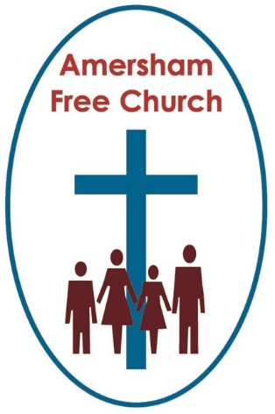
Choral Fanfare from the Jubilate Singers
Alleluia! Christ is risen!
Christ is risen! Alleluia!
Christ is risen! Christ is risen!
Christ is risen! Christ is risen!
Alleluia! Alleluia! Alleluia! (c) 2005 John Curtis/admin. The Jubilate Group CCL 257120
Easter Responses
Leader: Praise be to the God and Father
of our Lord Jesus Christ!
All: In his great mercy he has given us
a new birth into a living hope
through the resurrection of
Jesus Christ from the dead.
Leader: Christ is Risen!
All: He is risen indeed! Alleluia!
Leader: The Lord be with you
All: and also with you.

Hymn Sung by The AFC Chancel Singers R & S No. 232

1. Christ the Lord is risen today, Alleluia!
Let creation join to say: Alleluia!
raise your joys and triumphs high, Alleluia!
Sing, ye heavens; thou earth reply: Alleluia!

2. Love’s redeeming work is done, Alleluia!
fought the fight, the battle won, Alleluia!
lo! Our sun’s eclipse is o’er: Alleluia!
lo! He sets in blood no more: Alleluia!

3. Vain the stone, that watch, the seal; Alleluia!
Christ hath burst the gates of hell: Alleluia!
death in vain forbids him rise: Alleluia!
Christ hath opened paradise! Alleluia!

4. Lives again our glorious King; Alleluia!
where, O death, is now thy sting? Alleluia!
Dying once, he all doth save; Alleluia!
where’s thy victory, boasting grave? Alleluia!

5. Soar we now where Christ hath led; Alleluia!
following our exalted Head; Alleluia!
made like him, like him we rise; Alleluia!
our the cross, the grave, the skies. Alleluia!

6. Hail the Lord of earth and heaven! Alleluia!
Praise to thee by both be given; Alleluia!
thee we greet triumphant now, Alleluia!
hail, the Resurrection Thou! Alleluia!
Opening Prayer and Lord’s Prayer
Old Testament Reading read by Sara Autton
Isaiah 25.6-9
In this is the Word of the Lord
Thanks be to God
Church Life Focus
New Testament Reading read by Sara Autton
Mark 16.1-8
In this is the Word of the Lord
Thanks be to God
Hymn sung by the AFC Chancel Singers Tune: We Three Kings of Orient are

1. Like a candle in the night
flickering, dancing, far from bright -
shadows leaping
hostile greeting -
Bethlehem’s fragile light.

Refrain: O Light of life and light of love
Let us all your brightness prove
Each refining, set us shining -
all our darkness now remove.

2. Dawn of hope in Galilee
can your presence set us free?
Teaching, healing, truth revealing
Help us your light to see!
Refrain: O Light of Life…

3. Noonday dark on Calv’ry’s hill;
evil forces met to kill -
life relinquished,
hope extinguished -
But you are with us still. Refrain: O Light of Life…

4. Resurrection morning bright;
death is beaten in the fight
Jesus’ glory
now our story
all of us share his light! Refrain: O light of life… John Campbell. CCL 257210
Prayer before the Sermon standing
Minister: Let the words of my mouth
All: And the meditations of all our hearts
Minister: Be acceptable in your sight
All: O Lord, our rock, and our redeemer. Amen
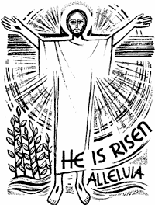
Sermon: Resurrection – A Defiance of Hopelessness
Prayers of Intercessions and Dedication using the prayer response
God of the Resurrection,
Bring your Spirit of Easter to them.
Hymn: sung by the AFC Chancel Singers R&S 448

1. Here, Lord, we take the broken bread
and drink the wine believing
that by your life our souls are fed
your parting gifts receiving.

2. As you have given, so we would give
ourselves for others’ healing;
and as you lived, so we would live,
the Father’s love revealing.
Holy Communion
The Peace all standing
Minister: The peace of the Lord be always with you
All: and also with you.
Minister: We say for one another:
All: The grace of our Lord Jesus Christ,
the love of God
and the fellowship of the Holy Spirit
be with us all evermore.
The Great Prayer of Thanksgiving
Minister: Lift up your hearts.
All: We lift them to the Lord.
Minister: Let us give thanks to the Lord our God.
All: It is right to give him thanks and praise.
Minister: Therefore with all your people
in heaven and on earth we worship
in the resounding hymn of your glory:
All: Holy, holy, holy Lord,
Sung by God of power and might,
The Chancel singers heaven and earth are full of your glory.
Hosanna in the highest.
Blessed is he who comes
in the name of the Lord.
Hosanna in the highest.
Words of Institution
Receiving bread and wine
Agnus Dei sung by The Chancel Singers
Jesus, Lamb of God: have mercy on us.
Jesus, bearer of our sins: have mercy on us.
Jesus, redeemer of the world, grant us peace

Post Communion Prayer
All O God who gives all that is good,
You have blessed the food and drink
we have received at your table.
As we now depart, may your grace
and laughter shine upon us,
your kindness be on our tongues,
your peace rest within us
and your love reign in our hearts. Amen
Hymn sung by The Chancel Singers R & S 247

1. Thine be the glory, risen, conquering Son,
endless is the victory thou o’er death hast won:
angels in bright raiment rolled the stone away,
kept the folded grave-clothes, where thy body lay:
Thine be the glory, risen, conquering Son,
endless is the victory thou o’er death hast won:

2. Lo Jesus meets us risen from the tomb;
lovingly he greets us, scatters fear and gloom;
let the Church, with gladness, hymns of triumph sing,
for her Lord now liveth, death hath lost its sting:
Thine be the glory, risen, conquering Son,
endless is the victory thou o’er death hast won:

3. No more we doubt thee, glorious Prince of Life;
life is naught without thee; aid us in our strife;
make us more than conquerors through thy deathless love;
bring us safe through Jordan to thy home above:
Thine be the glory, risen, conquering Son,
endless is the victory thou o’er death hast won!
Blessing standing with Amen sung by The Chancel Singers
Recessional
As the organ plays, we leave church, one row at a time, from the back.
If you wish to listen to the voluntary all the way through, then please remain in your seat until the end and then leave.
Please do not linger inside the building as you leave. Outside, in the car park, we observe the Rule of Six as we greet each other.

