**AMERSHAM FREE CHURCH  
Friday 18th April 2025 Good Friday 10.30am  
 A SERVICE OF REFLECTION** led by The Revd Ian Green and The Revd Erna Stevenson *Organist: Janet Reid*

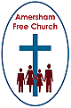

**Opening Responses:** *based on a prayer by Desmond Tutu*Leader: Today, around the cross, we gather to remember:  
**All: God’s love shown to us in Jesus.**Leader: We come to give thanks that:  
**All: Goodness is stronger than evil.  
 Love is stronger than hate.  
 Light is stronger than darkness.  
 And life is stronger than death.**Leader: The Lord be with you  
**All: And also with you**

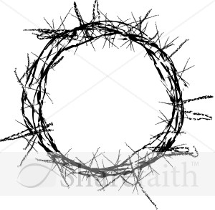

**Hymn 227:** Were you there **Opening Prayers   
and The Lord’s Prayer**

**Reading**: Matthew 27.20-26  
 (Church Bible page 27 NT) *Read by Gillian Munro*  
 **Reflection:** Washing our hands*followed by Silent prayer*

**Hymn:** Lord Jesus, for my sake you came *Tune R&S 416 Tallis’s Canon***1. Lord Jesus, for my sake you came,  
the Son of Man, and God most high;  
you leave behind your Father’s home  
to live and serve, to love and die.  
  
2. Your eyes seek out our world’s distress  
through insult, grief and agony;  
they meet our tears with tenderness  
yet blaze upon our blasphemy.  
  
3. Are these the robes that make men proud,  
is this the crown that you must wear?  
Your face is set, your head is bowed,  
and silently you persevere.  
  
4. You never grasped at selfish gain,  
and yet your hands are marked with blood;  
transfixed by nails, they cling in pain  
to sorrow on a cross of wood.  
  
5. Lord Jesus, come to me anew;  
your hands, your eyes, your thoughts be mine,  
until I learn to love like you  
and live on earth the life divine.**  *Michael Perry CCL 257120*

**Reading:** Mark 15.33-39  
 (Church Bible page 46 NT) *Read by Gillian Munro*

**Reflection:** A long day*followed by Silent Prayer*

**Hymn:** A crown of piercing thorns *Tune R&S 455 St Michael*  
**1. A crown of piercing thorns  
they forced upon your head:  
to claim and change my selfish mind  
your precious blood was shed.  
  
2. The flesh upon your back  
their brutal scourging tore:  
how can I shirk another’s load  
since you my burden bore?  
  
3. Lord, how can I forget  
the nail-prints on your hands?  
Make me a servant of your grace,  
fulfilling love’s demands.  
  
4. Your feet they firmly held  
as nails were hammered through:  
My feet are free – but how can I  
not choose to follow you?  
  
5. The spear which broke your side  
made blood and water flow;  
come, pierce my heart, that through my life  
your suff’ring love may show.  
  
6. You took my place in death,  
your blood was freely poured:  
Then let my life be spent for you,  
my Saviour and my Lord!** *Martin E.Leckebusch CCL 257120*

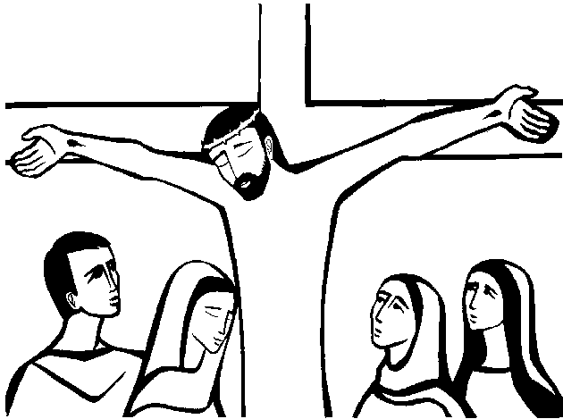

**Reflection:** Holy Saturday*followed by Silent Prayer*

**Hymn 223:** There is a green hill  **Intercessions   
  
Affirmation of Faith**

Minister: Let us stand and affirm our faith  
 and our confidence in the unconditional love of God.

**All: We believe in a God who always surprises us,   
 who creates life from death,  
 who brings good out of evil,   
 who leads us from despair to hope.**

**We believe in a God who is faithful to us,   
 who shows mercy when we run away, who shows patience when we deny the truth,   
 who gives reconciling love when we betray.**

**We believe in a God   
 who lived and died as one of us   
 to take the fear out of living and dying,   
 to open our eyes to death,   
 within us and around us,   
 and open our hearts to new ways of living.**

**We believe in a God who forgives us,  
 who sets us free from past grief and failure   
 and calls us forth into a new day.**

**Hymn 220:** O sacred head sore wounded  
  
**Dismissal and Blessing** *with sung Amen*